**FUNCTIONAL AND TECHNICAL COMBINED DOCUMENTATION**

**Page (4): Portfolio Action ---🡪 Stocks (Front End Url:** http://localhost:8100/page50/Page50)

**Functional Picture:**

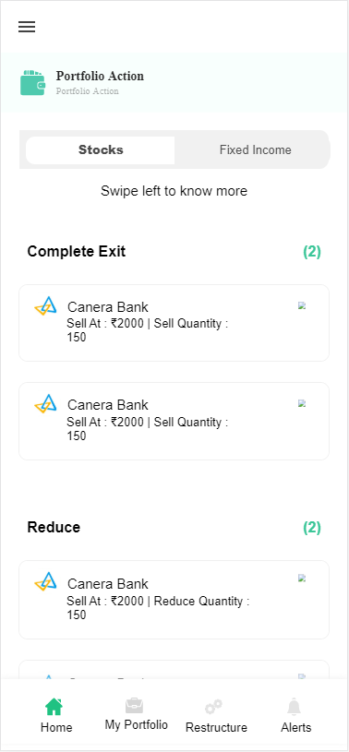

**Technical Explanations (Front End and Back End):**

**In Page50.tsx, we are calling following six API’s:**

1. **CheckingNewUserExistingPortfolioUSerAPI**: see view.py python file from BackEnd
2. **FinalPortfolioOutputforNewUserAPI**: see view.py python file from BackEnd
3. **EverdayFirstTimeUserPortfolioReconstruction**: see view.py python file from BackEnd
4. **ExistingPortfolioAPI**: see view.py python file from BackEnd
5. **PortfolioActionAPI**: see view.py python file from BackEnd
6. **EverdayExistingUserPortfolioReconstruction**: see view.py python file from BackEnd

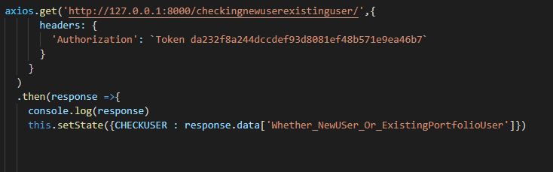

**As you can see in the above image, we are calling the API through this url(**[**http://127.0.0.1:8000/checkingnewuserexistinguser/**](http://127.0.0.1:8000/checkingnewuserexistinguser/)**). This url is calling CheckingNewUserExistingPortfolioUSerAPI** Api in the Back End. For the explanation of this API, Kindly look into:

**CheckingNewUserExistingPortfolioUSerAPI** Section which is explained below.

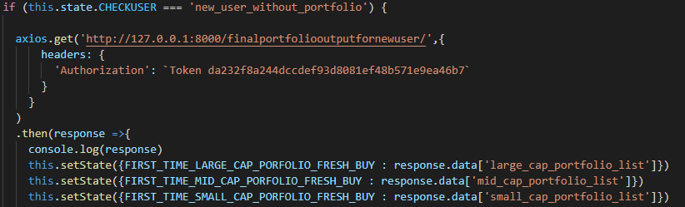

**As you can see in the above image, we are calling the API through this url(**[**http://127.0.0.1:8000/finalportfoliooutputfornewuser/**](http://127.0.0.1:8000/finalportfoliooutputfornewuser/)**), we are calling this url because the user lies in the category of “new_user_without_portfolio”. This url is calling FinalPortfolioOutputforNewUserAPI** Api in the Back End. For the explanation of this API, Kindly look into:

**FinalPortfolioOutputforNewUserAPI** Section which is explained below.

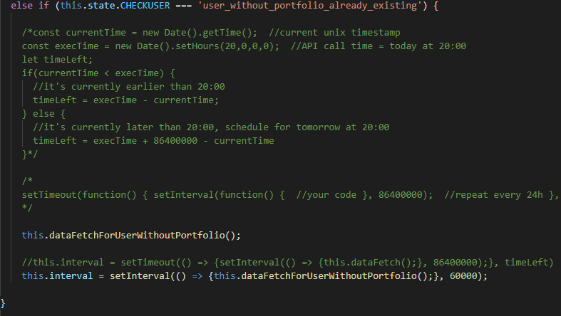

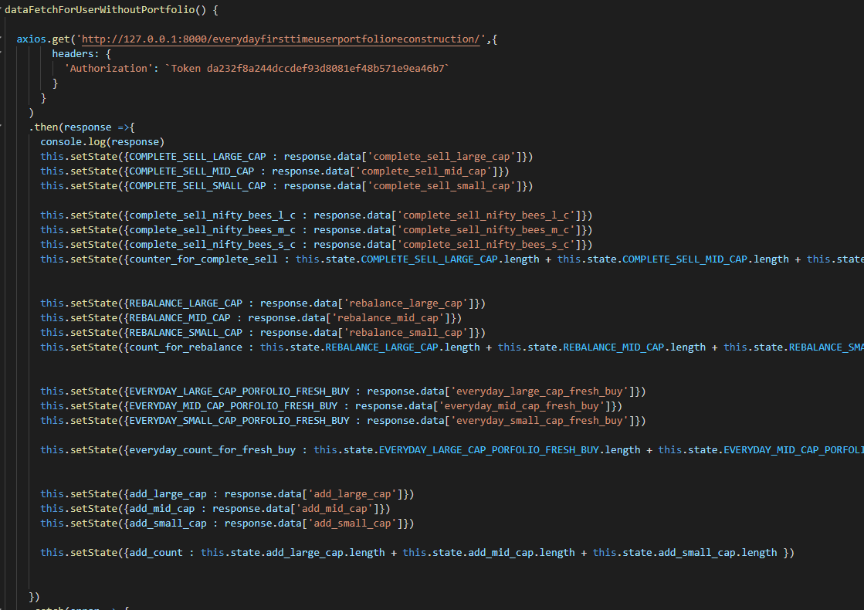

**As you can see in the above image, we are calling the API through this url(**[**http://127.0.0.1:8000/everydayfirsttimeuserportfolioreconstruction/**](http://127.0.0.1:8000/everydayfirsttimeuserportfolioreconstruction/)**), we are calling this url because the user lies in the category of “user_without_portfolio already exisiting”. This url is calling EverdayFirstTimeUserPortfolioReconstruction** Api in the Back End. For the explanation of this API, Kindly look into:

**EverdayFirstTimeUserPortfolioReconstruction** Section which is explained below.

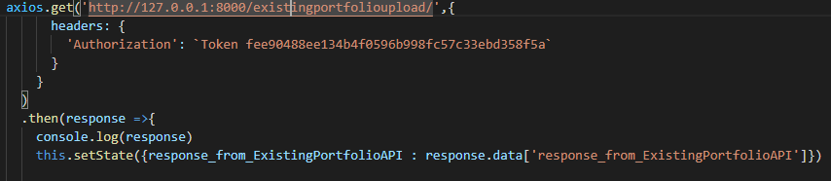

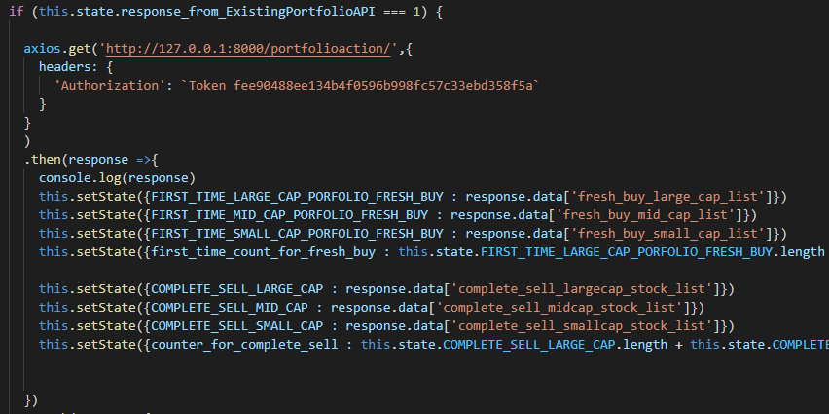

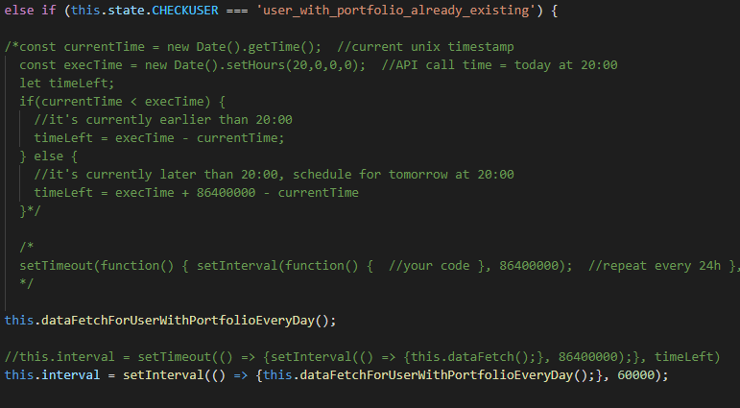

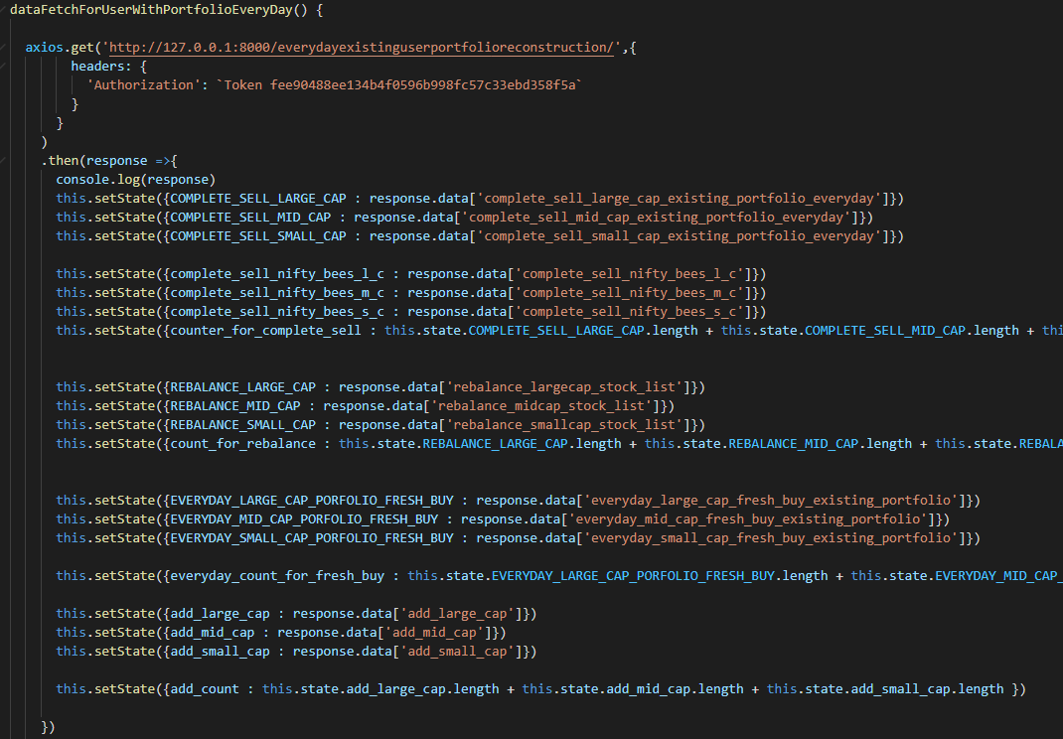

**API EXPLANATION:**

1. **CheckingNewUserExistingPortfolioUSerAPI:**

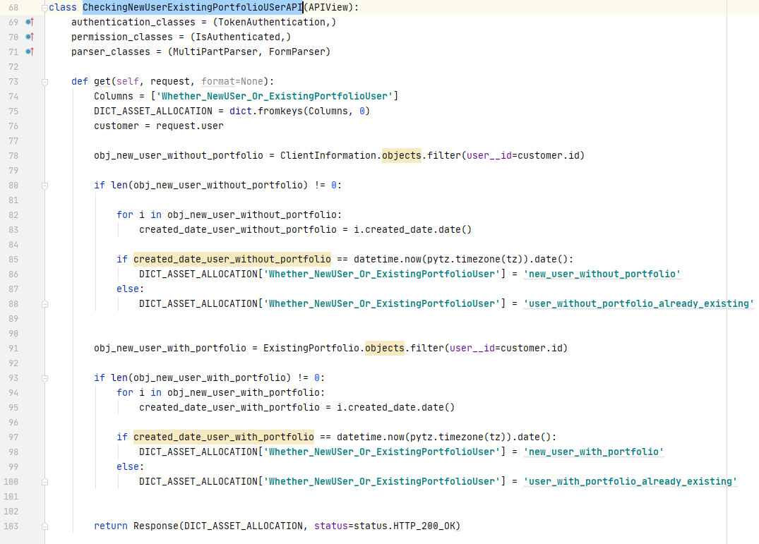

**In the code from line 78 to 88, we are taking the “created_date” field value from “ClientInformation” database model. We are using “ClientInformation” database for the users who do not have their existing portfolio.**

**After that we are checking whether the user joined today if his “created_date” matches with today’s date. If it matches with today’s date, then that user is “new_user_without_portfolio” else that user is “user_without_portfolio_already_existing”.**

**In the code from line 91 to 100, we are taking the “created_date” field value from “ExistingPortfolio” database model. We are using “ExistingPortfolio” database for the users who have their existing portfolio.**

**After that we are checking whether the user joined today if his “created_date” matches with today’s date. If it matches with today’s date, then that user is “new_user_with_portfolio” else that user is “user_with_portfolio_already_existing”.**

1. **FinalPortfolioOutputforNewUserAPI:**

**For Portfolio Construction we are using the below given doc:**

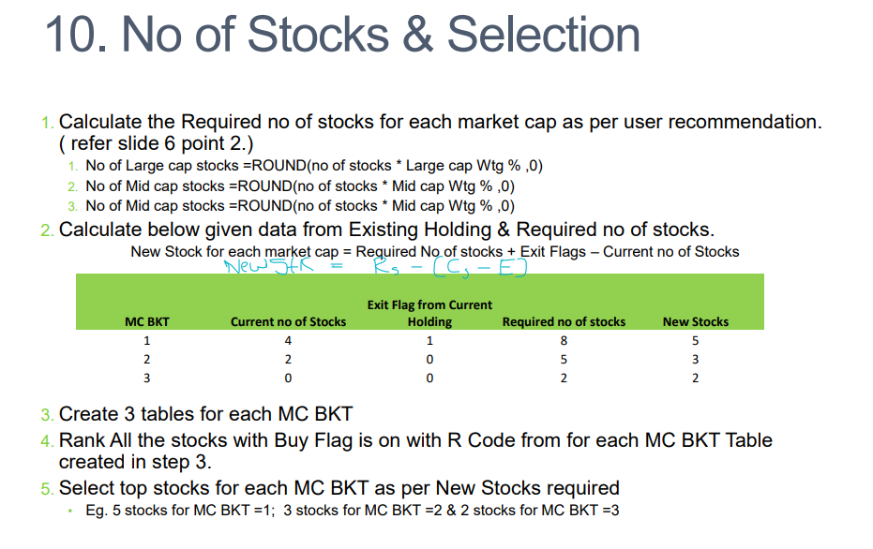

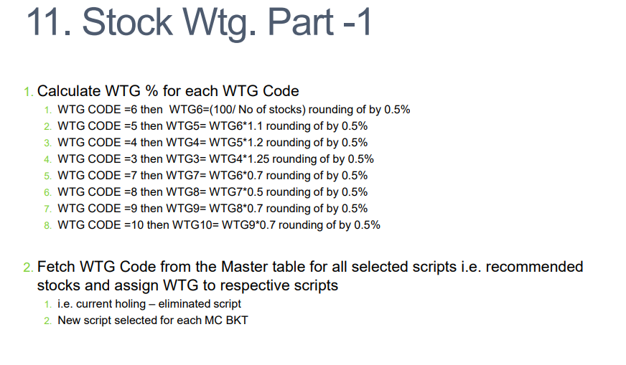

**Let get started!!**

**First we will Calculate the Required no of stocks for each market cap as per user recommendation.**

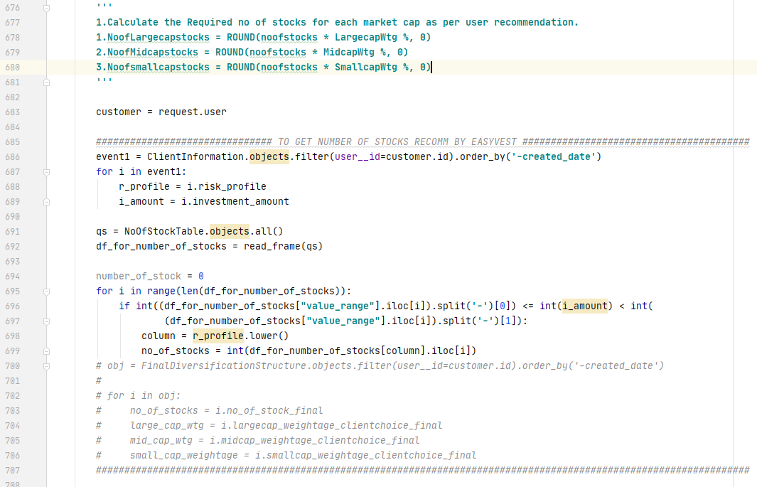

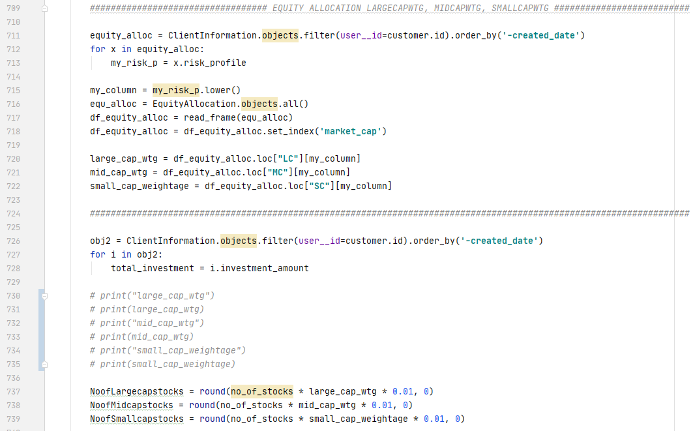

**From line 686 to 689 we are taking the risk profile and investment amount of that particular user. And with the help of that we are calculating the number of stocks recommended by EasyVest with the help of “NoOfStoackTable” database model.**

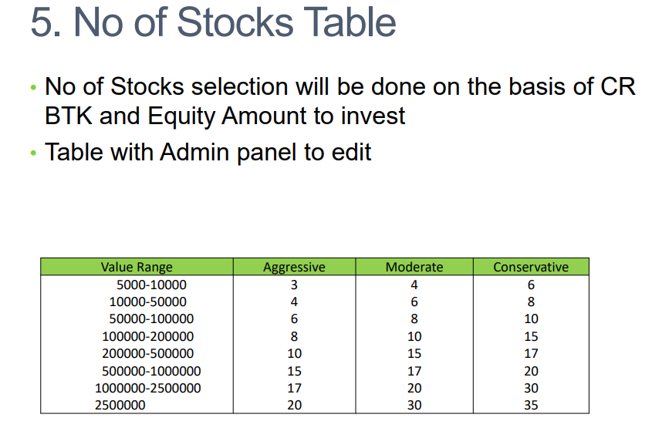

**From line 711 to 728 we are taking the risk profile and investment amount of that particular user. And with the help of that we are calculating the capital weightage for the large cap stocks, mid cap stocks and small cap stocks.**

**After that using the below given formula we are calculating the Number of stocks in each large, mid and small capitalization bucket, this can be seen in the code from line no 737 to 739.**

**Now Let’s get to the next step.**

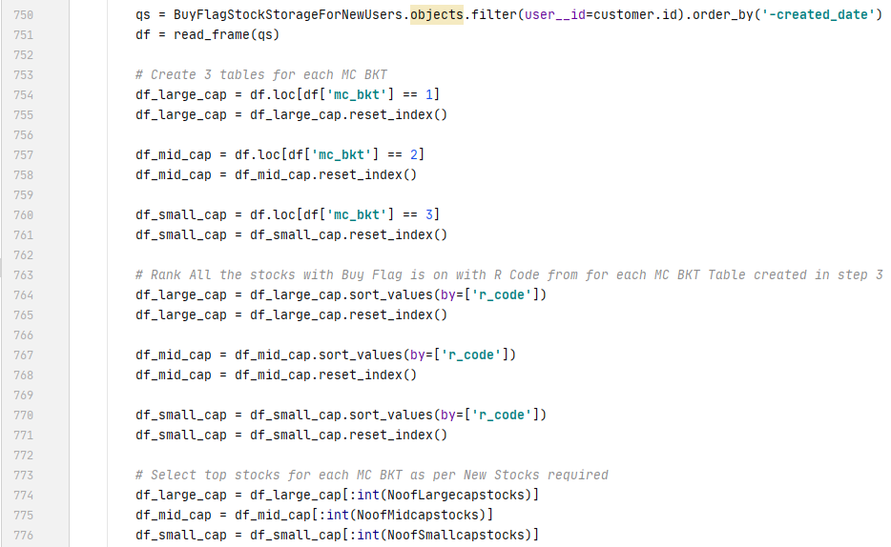

**As you can see, we are taking all the stocks from our Buy Flag, after that we are dissecting those stocks from the Buy Flag into three table large_cap, mid_cap and small_cap (see the line no. 754 to 761).**

**Now,** *Rank All the stocks with Buy Flag with R Code from for each MC BKT Table created in above steps (see line no. 764 to 772). After that select top stocks for each MC BKT as per New Stocks required (see line no 774 to 776)*

*Now, Calculate WTG % for each WTG Code*

**1. WTG CODE =6 then WTG6=(100/ No of stocks) rounding of by 0.5%   
2. WTG CODE =5 then WTG5= WTG6*1.1 rounding of by 0.5%   
3. WTG CODE =4 then WTG4= WTG5*1.2 rounding of by 0.5%   
4. WTG CODE =3 then WTG3= WTG4*1.25 rounding of by 0.5%   
5. WTG CODE =7 then WTG7= WTG6*0.7 rounding of by 0.5%   
6. WTG CODE =8 then WTG8= WTG7*0.5 rounding of by 0.5%   
7. WTG CODE =9 then WTG9= WTG8*0.7 rounding of by 0.5%   
8. WTG CODE =10 then WTG10= WTG9*0.7 rounding of by 0.5%**

**Kindly see utility function of above formula below:**

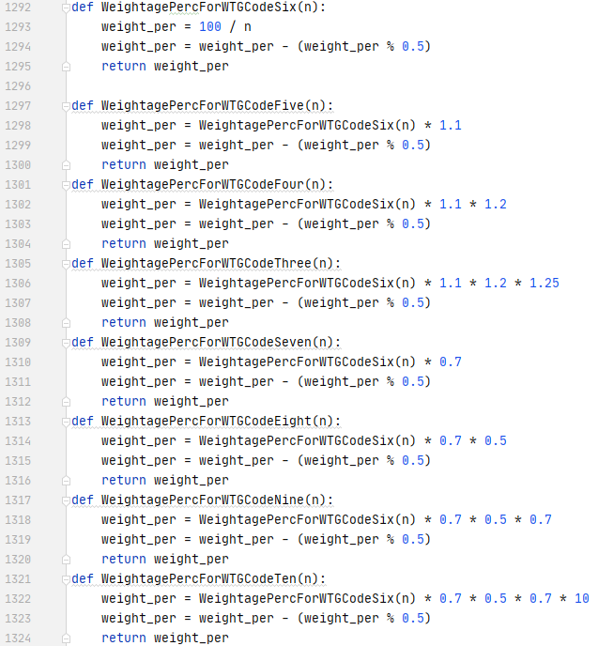

**Now, From line number 791 to 965 in the Back End code in view.py, we are** *calculating WTG % for each WTG Code in large cap, mid cap and small cap.*

*At this moment we have successfully created the portfolio for each MC bucket.*

*After this we are saving the calculated portfolio inside three databases:*

* FinalLargeCapPortfolio
* FinalMidCapPortfolio
* FinalSmallCapPortfolio

1. **EverdayFirstTimeUserPortfolioReconstruction:**